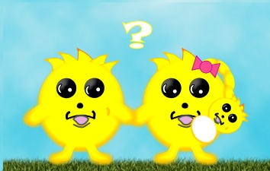Name: ____________________________________ Class: _____ Date: ______________

**Snurfle Meiosis**

* **Click on Snurfle Meiosis App**
* **Click on Continue**
* **Click on Continue**
* **Click on Meiosis and Genetics Interactive and follow the instructions as you answer the questions.**

1. When does interphase occur? _________________________________________________________________
2. What occurs during interphase? ________________________________________________________________
3. Uncoiled stringy DNA is called ________________________________.
4. Human cells have _____________ pieces of chromatin.
5. Half of your DNA comes from your _______________________ and half from your ________________.
6. DNA has _____________________ that determine traits of an organism.
7. Different forms of a gene are called _____________________.
8. List the 2 alleles for fur color in Snurfles & the letter that represents those alleles? _________________ and _______________.
9. ____________________________ is when DNA copies itself and it occurs during ________________________.
10. _________________________ are made during meiosis. Examples of gametes are _________ & ____________.
11. Meiosis occurs in _____ divisions; Meiosis ____ and Meiosis _______
12. List the phases for Meiosis I. ________________, __________________, _________________, ______________
13. List the phases for Meiosis II. ________________, __________________, _________________, ______________
14. During prophase I the chromosomes __________________ and become ______________________.
15. Chromosomes that are the same size and have the same genes are called __________________ _____________
16. Each half of a replicated chromosome is called a ____________________________________________________
17. Sister chromatids of a chromosome are identical _______________________________.
18. The nucleus ________________during prophase.
19. Homologous chromosomes pair up during prophase I to form a __________________.
20. During metaphase I the tetrads line up in the ____________________ of the cell.
21. The homologous chromosomes split up and move toward the opposite ends of the cell during _________________.
22. ______ independent cells begin to form during _________________________.
23. __________________________ is the division of the cytoplasm to make two new cells.
24. The 2 new cells that are formed from Meiosis I are _____________ because they contain half of the chromosome of the original cell that started meiosis.
25. At the start of Meiosis I you had 1 ____________ cell.
26. Meiosis II must take place because each of our new cells still has too much ______________.
27. 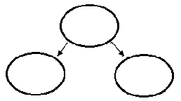Draw the chromosomes in Meiosis I. **Label the cells as diploid or haploid.**
28. The nucleus ______________________ during prophase II.
29. In Metaphase II the chromosomes line up single file down the __________________ of the cell.
30. In ___________________ the sister chromatids split up.
31. In Telophase II, _____ ___________ daughter cells are being formed.
32. They are called _______________.
33. Each newly formed cell will form a ________________________ around the chromosomes.
34. The chromosomes ____________________ to form ______________________.
35. ____________________________ occurs at the same time at Telophase II.
36. At the end of Meiosis II you have made ____ _____________ gametes (sex cells).
37. Draw and label the Meiosis Summary.

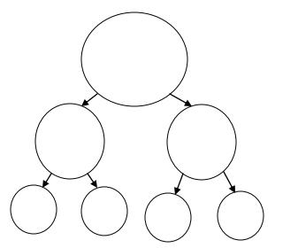

1. If the gametes are produced by a female they are called __________________ or _______________.
2. If the gametes are produced by a male they are called ________________.
3. The _______________ square is a tool that is used to predict possible offspring of a genetic cross.
4. The letters on a Punnett square actually represent possible _____________________.
5. When sperm and egg join it is called ______________________ which is a fertilized egg.
6. Complete the Punnett square to the right.
7. 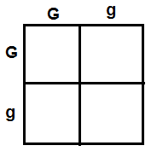A _________________ is the genetic make-up of an organism.
8. _____________ and ___________ are examples of genotypes.
9. A __________________ is the characteristic or appearance of the organism.
10. ____________________ & ________________ are examples of phenotypes.
11. Dominant alleles are represented by ___________________________ letters.
12. Recessive alleles are represented by ____________________________________ letters.
13. ____________________________ alleles will show in your phenotype even if it has one copy.
14. For recessive traits to show in the phenotype, the snurfle will need ____ copies of the gene.
15. __________________________ means an organism has 2 copies of the same allele in its genotype (GG,gg)
16. __________________________ means an organism has 2 different alleles in its genotype (Gg, Tt, Rr)

* Click on the chromosome Quandry and follow the directions
* Click on the Meiosis and Genetics Quiz! Answer the questions
* Click on the Score Sheet and record your scores in the table below.

|  |  |  |  |  |
| --- | --- | --- | --- | --- |
| **Overall Score** | **Meiosis** | **Genetics** | **Chromosome Quandary** | **Quiz** |
|  |  |  |  |  |