Activity on Interpreting Statistical Data
Name: _________________________ Class: ______ Date: ___________

Now it is time to put your interpretation skills to the test!

With reference to the graph provided below, answer the questions in the worksheet. Remember the 3 steps to help you interpret data.

Singapore’s Elderly Population by Age Group
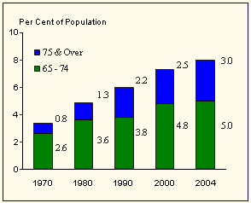
Source: http://www.singstat.gov.sg/keystats/annual/indicators.html#Population%20Indicators
Courtesy of Singapore Department of Statistics

Step 1: Reading the data
What does the graph tell you about the elderly in Singapore between 1970 and 2004?
______________________________________________________________
______________________________________________________________
______________________________________________________________
______________________________________________________________
______________________________________________________________
______________________________________________________________
______________________________________________________________
______________________________________________________________

Step 2: Explaining the data
What do you think are some of the reasons for this trend?
______________________________________________________________
______________________________________________________________
______________________________________________________________
______________________________________________________________
______________________________________________________________
______________________________________________________________
______________________________________________________________
______________________________________________________________
Step 3: Inferring from the data
How do you think this trend may pose a challenge to Singapore’s economic development in the future?
______________________________________________________________
______________________________________________________________
______________________________________________________________
______________________________________________________________
______________________________________________________________
______________________________________________________________
______________________________________________________________
______________________________________________________________

- End of Worksheet -

