XINGNAN PRIMARY SCHOOL
WORKSHEET TOPIC: VOLUME
Complete Worksheet
- Fill in the blanks.
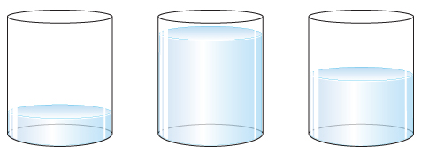
A B C

Container _______________ has the least amount of water.

Container _______________ has the most amount of water.

- Fill in the blanks.

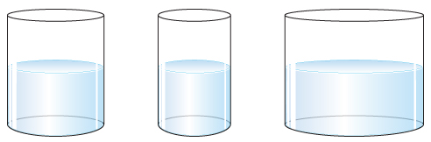
A B C

Container _______________ has the most amount of water.

Container _______________ has the least amount of water.
- Fill in the blanks.

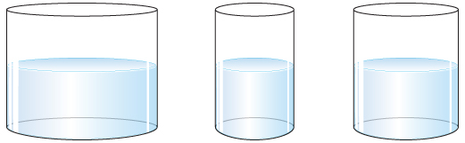
A B C

Container C contains more water than container ________.

Container C contains less water than container _________.

--END--

